2026 Horseshoe Tour Schedule

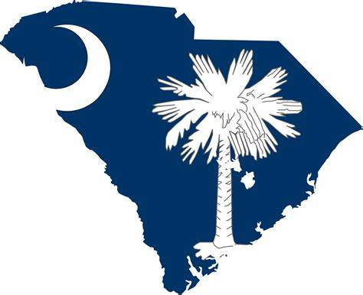 Newberry, SC April 18-19, 2026
Sue Snyder/SummerFun
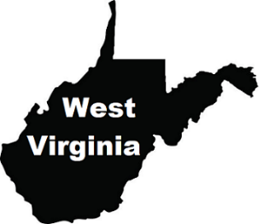Ronceverte, WV May 30-31, 2026
Mountaineer Open
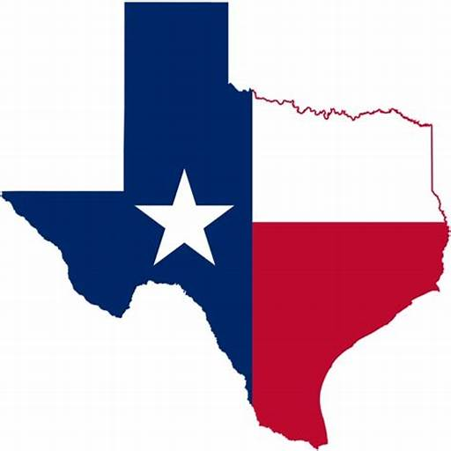 Buffalo, TX September 12-13, 2026
Lone Star Shootout
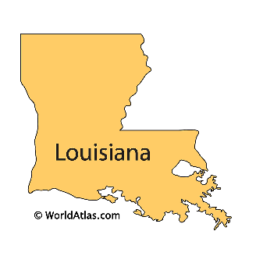 Patterson, LA October 17-18, 2026
Cajun Coast Classic

** Additional events may be added at a later date.

